3.0 Project Planning
3.1 Use Case Diagram
A use case diagram in the Unified Modeling Language (UML) is a type of behavioral diagram defined by and created from a Use-case analysis. Its purpose is to present a graphical overview of the functionality provided by a system in terms of actors, their goals (represented as use cases), and any dependencies between those use cases.
The main purpose of a use case diagram is to show what system functions are performed for which actor. Roles of the actors in the system can be depicted.
A use case is a technique used in software and systems engineering to capture the functional requirements of a system. Use cases describe the interaction between a primary actor—the initiator of the interaction—and the system itself, represented as a sequence of simple steps.
Actors are something or someone which exist outside the system under study, and who (or which) take part in a sequence of activities in a dialogue with the system, to achieve some goal: they may be end users, other systems, or hardware devices. Each use case is a complete series of events, from the point of view of the actor.
Interaction among actors is not shown on the use case diagram. If this interaction is essential to a coherent description of the desired behavior, perhaps the system or use case boundaries should be re-examined. Alternatively, interaction among actors can be part of the assumptions used in the use case.

Use Case for Admin :

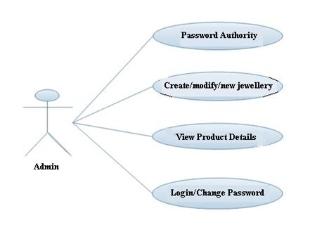

Use Case for User :

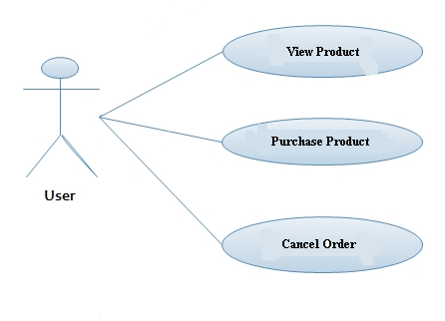

3.2 Data Flow Diagram
A data-flow diagram (DFD) is a graphical representation of the "flow" of data through an information system. DFDs can also be used for the visualization of data processing (structured design).
On a DFD, data items flow from an external data source or an internal data store to an internal data store or an external data sink, via an internal process.
A DFD provides no information about the timing or ordering of processes, or about whether processes will operate in sequence or in parallel. It is therefore quite different from a flowchart, which shows the flow of control through an algorithm, allowing a reader to determine what operations will be performed, in what order, and under what circumstances, but not what kinds of data will be input to and output from the system, nor where the data will come from and go to, nor where the data will be stored (all of which are shown on a DFD).
Data-flow diagrams (DFDs) are one of the three essential perspectives of the structured-systems analysis and design method SSADM. The sponsor of a project and the end users will need to be briefed and consulted throughout all stages of a system's evolution. With a data-flow diagram, users are able to visualize how the system will operate, what the system will accomplish, and how the system will be implemented.
The old system's dataflow diagrams can be drawn up and compared with the new system's data-flow diagrams to draw comparisons to implement a more efficient system. Data-flow diagrams can be used to provide the end user with a physical idea of where the data they input ultimately has an effect upon the structure of the whole system from order to dispatch to report. How any system is developed can be determined through a data-flow diagram.

3.2.1Context Diagram
A System Context Diagram (SCD) in software engineering and systems engineering are diagrams that represent the actors outside a system that could interact with that system. This diagram is the highest level view of a system, similar to Block diagram, showing a, possibly software-based, system as a whole and its inputs and outputs from/to external factors. System Context Diagram are diagrams used in systems design to represent the more important external actors that interact with the system at hand. This type of diagram according to Kossiakoff (2003) usually "pictures the system at the center, with no details of its interior structure, surrounded by all its interacting systems, environment and activities.
The objective of a system context diagram is to focus attention on external factors and events that should be considered in developing a complete set of system requirements and constraints".
System context diagrams are related to Data Flow Diagram, and show the interactions between a system and other actors with which the system is designed to interface. System context diagrams can be helpful in understanding the context which the system will be part of.

Context diagrams can be developed with the use of two types of building blocks:
labeled boxes: one in the center representing the system and around it multiple boxes for each external actor
Relationship: labeled lines between the entities and system

Context Level DFD

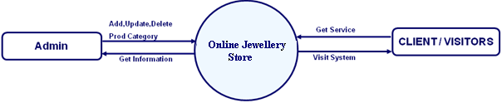

First Level DFD for Admin 1.0

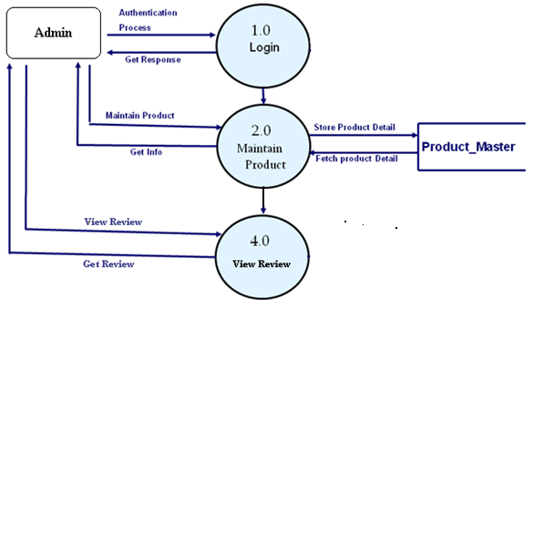
Second Level DFD for Admin process 2.0

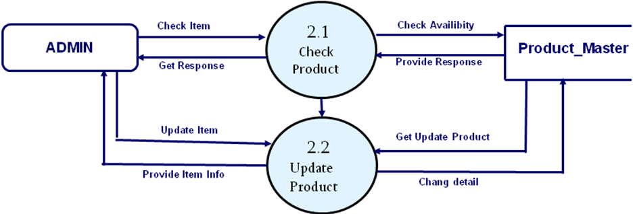

First Level DFD for Client

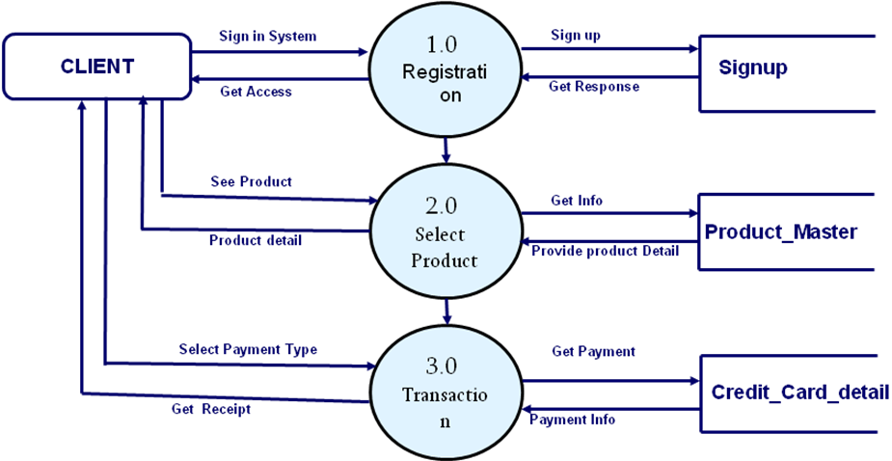

Second Level DFD for Client 1.0

